Obtaining Ivey Publishing Case Studies
$5.30 CAD Printed Copy (does not include shipping costs)
$4.50 CAD Digital Download

- Go to the Ivey Publishing website at www.iveycases.com
- Log in to your existing account or click "Register" to create a new account and follow the prompts to complete the registration. If registering, choose the "Student User" role.
- Click on this link or copy into your browser: https://www.iveycases.com/ProductView.aspx?id=65427
- Click "Add to Cart".
- You may choose to order in either print or digital format.
  - To order the material in digital format, check "digital download" and click "OK".
  - To order a printed copy for delivery, enter the print quantity required and click "OK". Please note that shipping charges will apply.
- Go to the Shopping Cart (located at the top of the page), click "Checkout", and complete the checkout process.
- When payment has been processed successfully, an Order Confirmation will be emailed to you immediately and you will see the Order Confirmation screen.
  - If you ordered digital copies: Click "Download your Digital Items" or go to "My Orders" to access the file.
  - If you ordered printed copies: Your order will be printed and shipped within 2 to 3 business days.
NOTE: Students may occasionally get the error message depicted in the graphic below when they try to purchase the case study. The link is not actually broken; rather students need to login in order to purchase the case study as per the case study instructions.
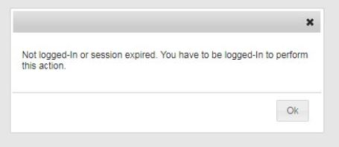
IMPORTANT: Access to downloadable files will expire 30 days from the order date, so be sure to save a copy on your computer. The downloadable file is a PDF document that can be opened using Adobe Reader.
This material is for your personal use only and is not to be shared or distributed in any form.

Questions? Contact Ivey Publishing during business hours.
Ivey Publishing
Ivey Business School
Western University
e. cases@ivey.ca
t. 519.661.3208 | f. 800.649.6355
www.iveycases.com
Business Hours:
Monday to Thursday: 8:00am-4:30pm (ET)
Friday: 8:00am-4:00pm (ET)

